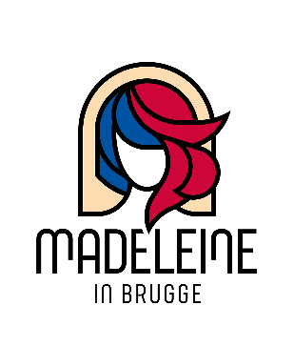
Madeleine in Brugge – Intake Form

Request for the use of Holy Magdalena Church and Rectory
Stalijzerstraat 19, Bruges, BELGIUM

Send the filled in form to: hemelsplan@yot.be

Name of the organisation

Name of the contact person

Title of the activity

Type of activity and a short description about the activity
(concert, conference, meditation, dinner, exhibition, reception, ritual, congress, meeting, memorial, lecture, workshop etc.)

E-mail address of contact person

Mobile Number

Website

Full address of the Organisation/Company

Full name, title and contact information of the legal representative of the organisation or company (with the authority to sign contracts)

Date of the planned activity / Desirable dates in order of priority

Duration of the activity
(including preparation, activity itself, dismantling, etc.)

Start time:
End time:
(if not on the same dates, mention the dates as well)
For how many people?

Do people have to pay for your activity?

Do you want to make use of the Rectory (with garden)?

Do you need catering?

Yes/No

(Your own catering at our venue is not possible)

Any other questions or need more info?

How or where did you hear about / get to know Madeleine in Brugge?

